Retro Bytes – User Guide
This guide explains how to use the Retro Bytes application features and exercise the defined use cases.

1. Getting Started
- Launch the application (see Build & Setup Guide).
- Open http://localhost:8080 in your browser.
- Navigation: Home, Search, Cart, Wishlist appear in the header.

2. Features Overview
- Browse categories and product details (with price and condition).
- Check local stock availability by ZIP/region (In stock/Low/Out).
- Search by keyword; filter by category and condition (First-hand/Second-hand).
- Add to cart; adjust quantity during checkout; place order to receive an Order ID.
- Save items to Wishlist; view and remove saved items.

3. Use Cases (Step-by-Step)
UC-1 Browse Catalog by Category
- From Home, click a category (e.g., Retro Consoles).
- Scroll the product grid; click a product to view details.
- Return to Home or switch categories from the header.
UC-2 Check Local Stock Availability
- Open a product page (e.g., /product/gbc-001).
- Enter your ZIP/region (e.g., 20742) and click Check.
- The page shows In stock / Low stock / Out of stock with notes.
UC-3 Add Item to Cart & Place Order
- On a product page, click Add to Cart.
- Open the Cart (header) → Review items and total → Checkout.
- Enter name, email, region/ZIP, and choose delivery or pickup.
- Click Place Order → You’ll be redirected to /order/<id> with details.
UC-4 Search & Filter by Condition
- Open Search (header).
- Enter a keyword (e.g., game) and click Apply.
- Optionally select Category and Condition filters; click Apply again.
- Open a product from results to view details.
UC-5 Wishlist
- On any product page, click Save to Wishlist.
- Open Wishlist (header) to see saved items.
- Click Unsave to remove an item.

4. Screenshots
- Home (categories)
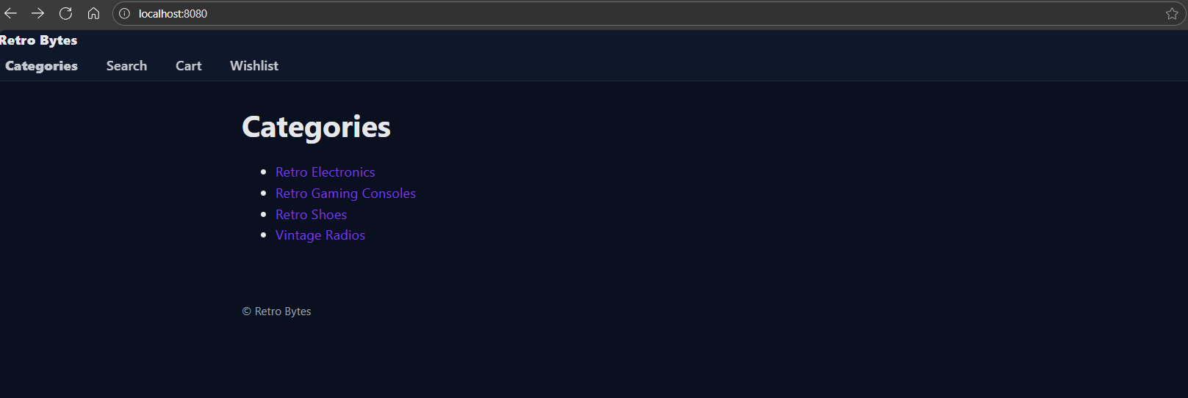
- Category (grid)
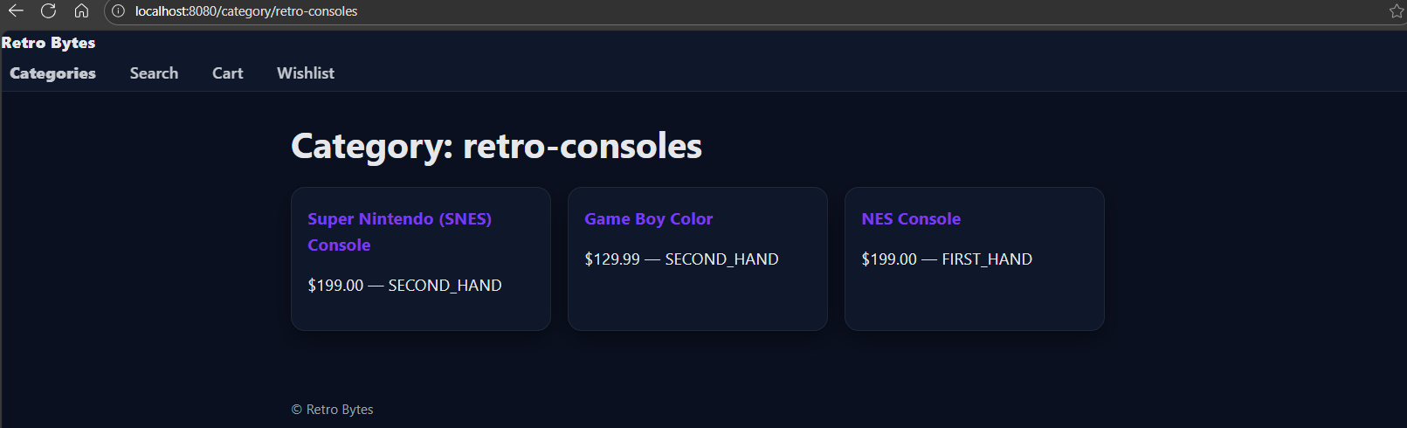
- Product
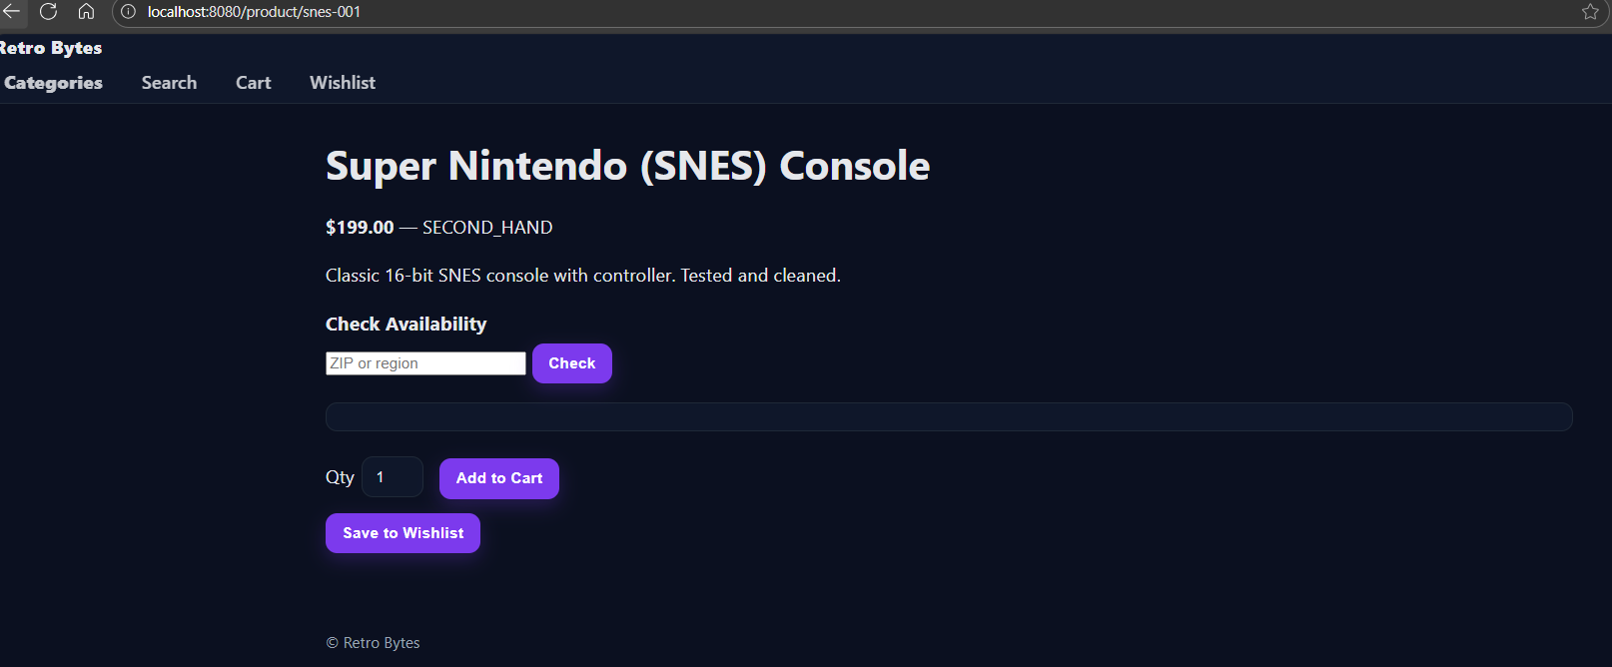
- Availability check
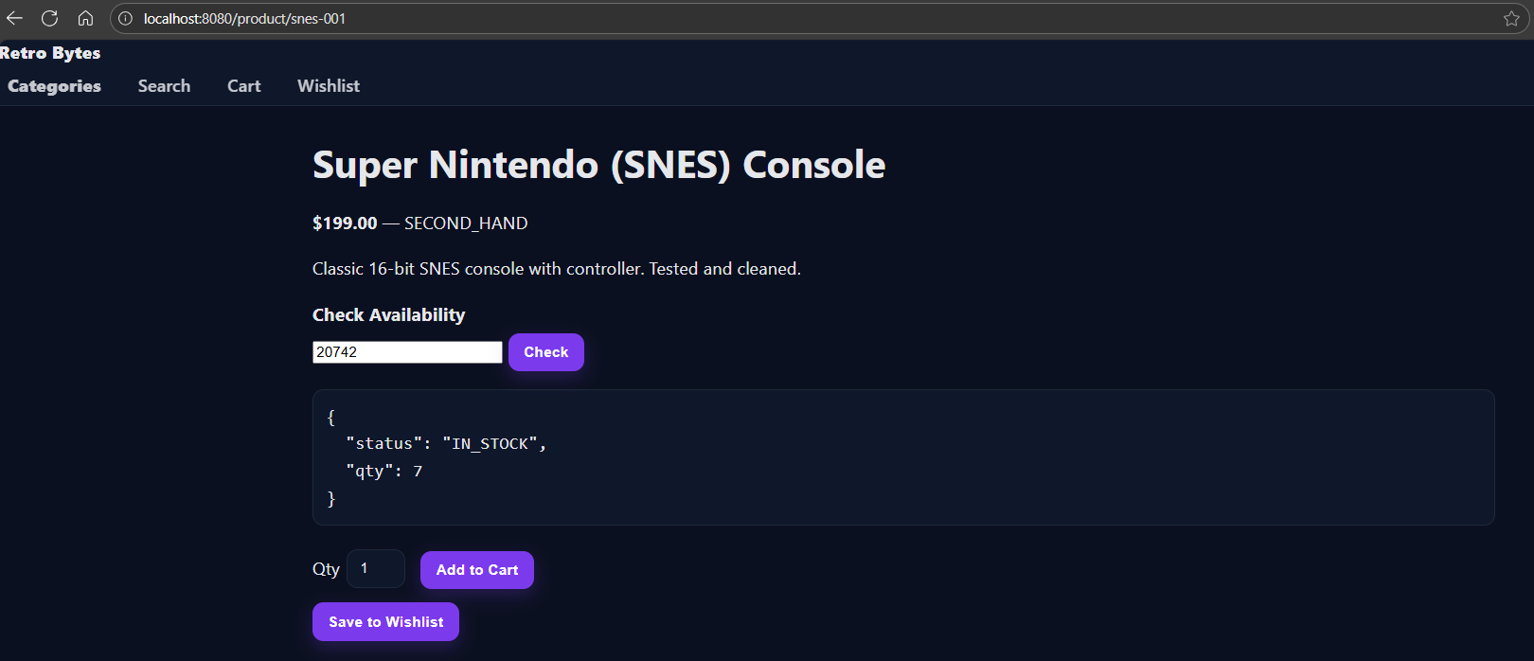
- Cart
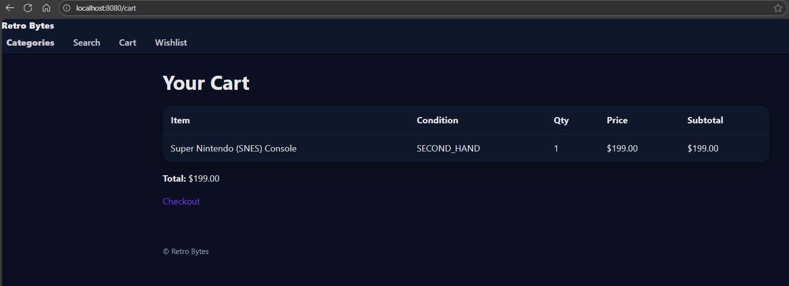
- Checkout
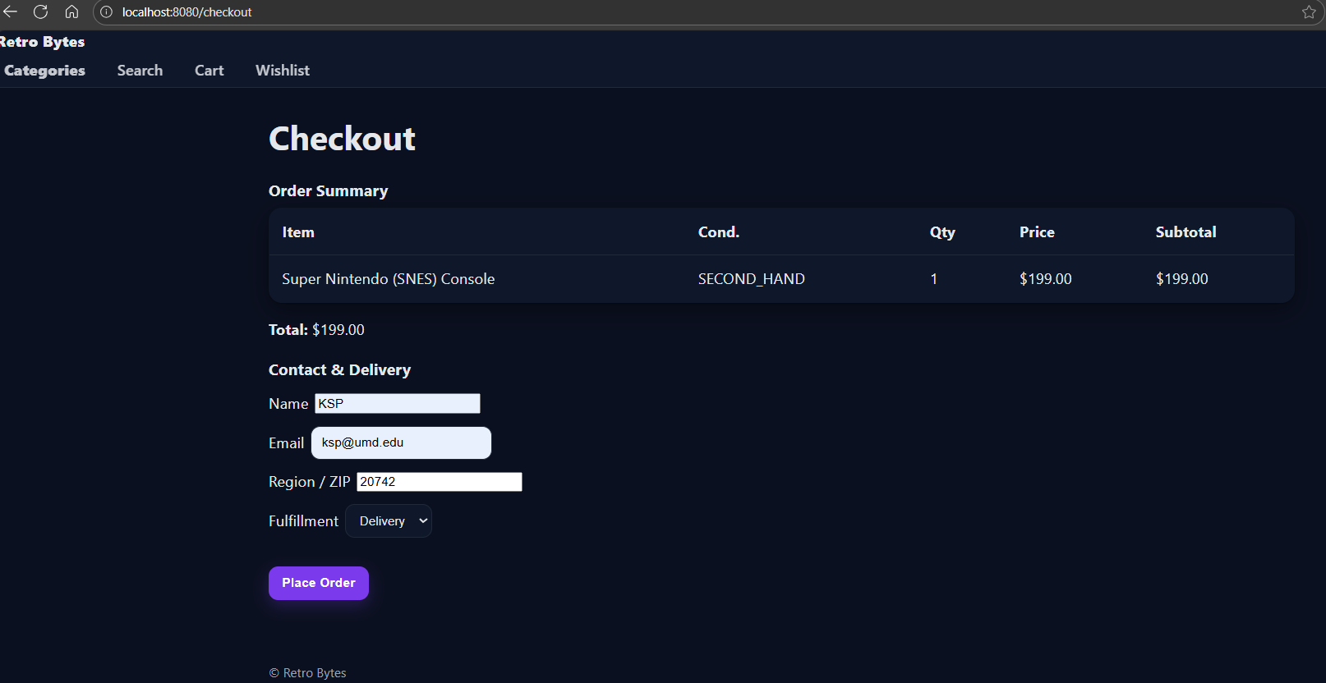
- Order confirmation
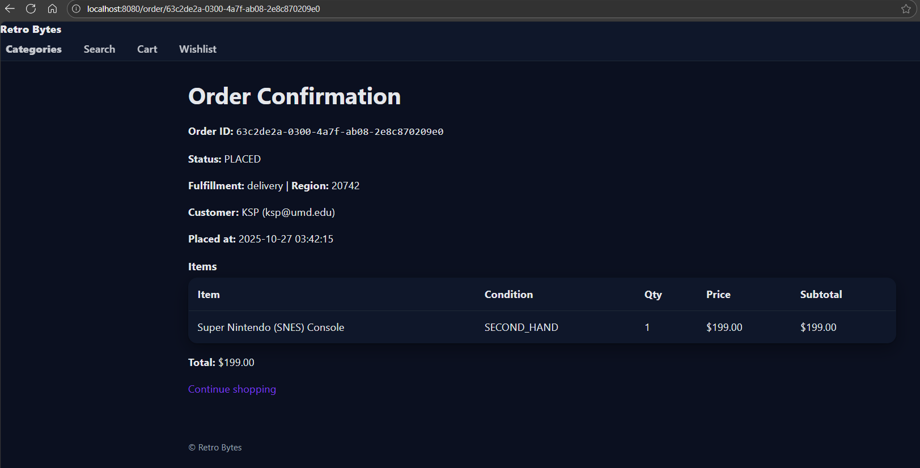
- Wishlist
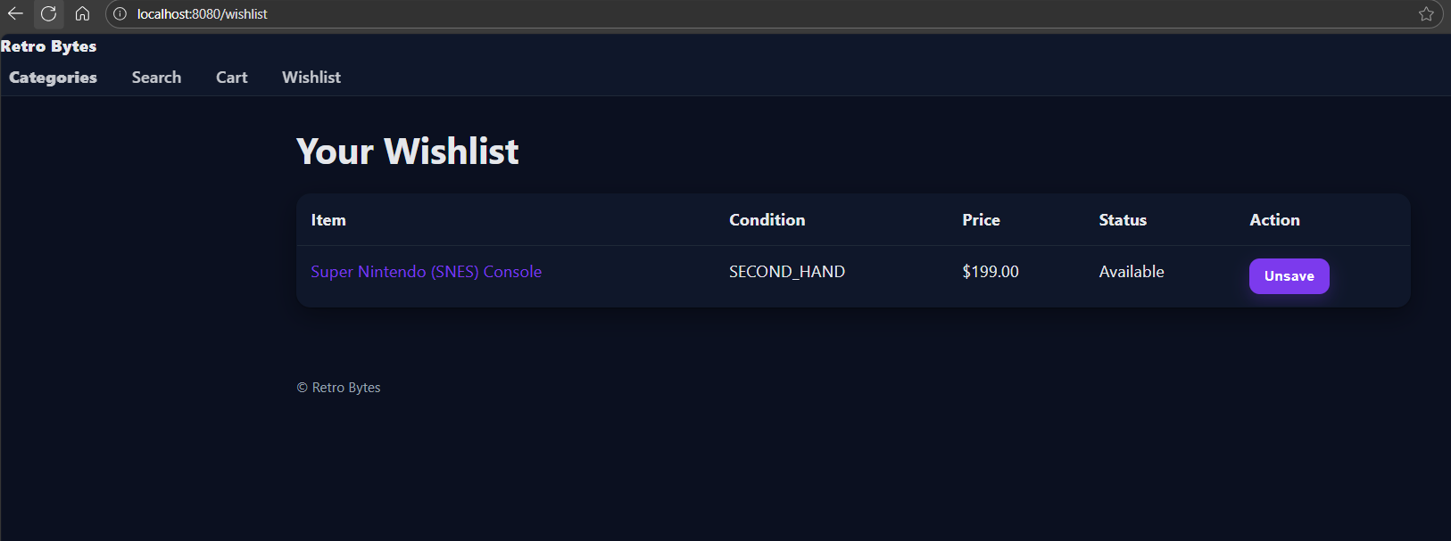
- Search results
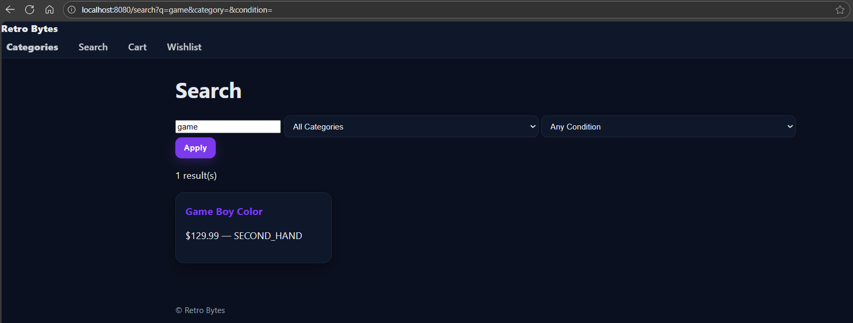

5. Troubleshooting (User-Facing)
- Empty categories/products → First run seeds the DB; refresh page or restart the app to reseed.
- Availability won’t show → Ensure a valid ZIP/region (e.g., 20742).
- Cannot place order → Ensure name and a valid email are entered; item must be in stock.
- Wishlist is empty after saving → Ensure cookies are enabled; try saving again and open /wishlist.
- Images missing → Ensure /media/products/<id>/main.jpg exists.

6. Accessibility & Notes
- Keyboard navigation: links/buttons are focusable; forms are label-connected.
- Contrast and dark-mode are supported via CSS variables.
- A session cookie is used to keep your cart and wishlist (no personal data stored).

